Type 11R Medical Face Masks

Size: 175mm x 95mm
Material: Melt-blown fabric 30%, non-woven fabric 70%
Net weight: 3.0g/pc
Model:
Product code: TYPE 11R

Packed : 40 units per box; 50 boxes per carton; 2,000 units per carton

Pack Markings: Type 11R Disposable Medical Face Masks
Qty: 50pcs

Carton Markings: TYPE 11R Disposable Medical Face Masks
Size 52 x 38 x 30 cm
Qty 2000 pcs (40x50 pcs)
PO: XXXX

Carton details are as follows.

The weight of the carton is 8 kg.

Inner Box Barcode

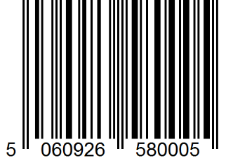

Carton Barcode

